**Abstract:**

**Graph generative model:**

A graph generative model is a type of machine learning model that is designed to generate graphs. These models learn the underlying patterns and structures of existing graphs and can then generate new, similar graphs. Graph generative models have applications in various fields, including chemistry, social network analysis, biology, and recommendation systems.

**Graph discriminative model:**

A discriminative graph model refers to a type of machine learning model that is designed for the task of discriminating between different classes or labels within a graph-structured dataset. In other words, it focuses on learning a decision boundary that separates different classes in the graph. Discriminative graph models are used for tasks such as node classification, link prediction, and graph classification.

**Adversarial training:**

Adversarial training is a machine learning technique that involves training a model in a competitive setting, where two neural networks, known as the generator and the discriminator, are engaged in a game-like scenario. This approach was introduced in the context of Generative Adversarial Networks (GANs) by Ian Goodfellow and his colleagues in 2014. However, adversarial training has since been applied in various machine learning tasks beyond GANs.

**Generative Adversarial Networks (GANs):**

Generative Adversarial Networks (GANs) are a class of artificial intelligence algorithms used in unsupervised machine learning.

The key innovation behind GANs is the use of a generative model and a discriminative model, which are trained simultaneously through adversarial training.

GANs have found applications in various domains and have been used for tasks such as image generation, style transfer, image-to-image translation, and more.  
  
**How GANs Work:**

**Training Setup:**

The generator and discriminator are trained simultaneously in a competitive manner.

The generator aims to produce samples that are indistinguishable from real data, while the discriminator aims to correctly classify whether a given sample is real or generated.

**Adversarial Training:**

The generator and discriminator are trained iteratively in a game-like setting. The generator gets better at generating realistic samples over time, while the discriminator improves its ability to distinguish real from fake.

**Objective Function:**

The objective is to minimize a loss function that captures the adversarial nature of the training process. The generator tries to maximize the probability of the discriminator making a mistake, while the discriminator aims to minimize this probability.

**Multi-scale Analysis of Graphs:**

**Multi-scale analysis of graphs refers to the exploration and representation of graph-structured data at multiple levels of granularity or scales. It involves analyzing the structural and topological properties of a graph at different resolutions, capturing both local and global patterns. This concept is particularly useful for understanding complex systems where entities interact with each other in various ways.**

**Hierarchical Representation:**

**Graphs are often hierarchical in nature, with nodes forming local clusters or communities, which, in turn, can be part of larger structures. Multi-scale analysis aims to capture this hierarchy.**

**Resolution Levels:**

**Different resolution levels in multi-scale analysis correspond to different levels of detail. Lower resolutions might capture global patterns, while higher resolutions focus on local structures.**

**Community Detection:**

**Community detection algorithms are often employed as part of multi-scale analysis to identify groups of nodes that are more densely connected internally than with the rest of the graph.**

**Scale-Specific Measures:**

**Various metrics and measures can be used at different scales, such as local clustering coefficients, betweenness centrality, or modularity.**

**Cycle consistency:**

**Cycle consistency is a concept in machine learning, particularly in the context of generative models and image-to-image translation tasks. It refers to the idea that if you perform a certain transformation on a data instance and then reverse that transformation, you should obtain a result similar to the original instance. This is often used as a regularization constraint during training to ensure the consistency and reversibility of the learned transformations.  
The concept is notably applied in cycle-consistent generative models, such as CycleGAN (Cycle-Consistent Generative Adversarial Network). Let's break down the key components:**

**Generative Adversarial Network (GAN):**

**A GAN consists of a generator and a discriminator. The generator aims to generate realistic data samples (e.g., images), while the discriminator tries to distinguish between real and generated samples.**

**Image-to-Image Translation:**

**CycleGAN, for instance, is designed for image-to-image translation tasks, where the generator learns to convert images from one domain to another without paired training data.**

**Cycle Consistency Loss:**

**In addition to the adversarial loss used in GANs, CycleGAN introduces a cycle consistency loss. This loss ensures that if an image from domain A is translated to domain B and then back to domain A, it should be similar to the original image. Similarly, if an image from domain B is translated to domain A and then back to domain B, it should also be similar to the original.**

**Coarse graphs:**

**The term "coarse graph" typically refers to a graph that has been simplified or down sampled in some way, resulting in a reduced level of detail compared to the original or "fine" graph. This simplification is often done for computational efficiency, visualization purposes, or to highlight higher-level structures or patterns within the graph. The process of creating a coarse graph involves aggregating or grouping nodes and edges from the original graph, resulting in a more generalized representation.**

**Misc-GAN:**

Graphs are fundamental for modeling complex systems in various domains, such as finance, drug discovery, and social network analysis.

Generative models are used for creating synthetic graphs, beneficial in scenarios like financial fraud detection, where third parties need to conduct empirical studies without revealing private information.

Traditional graph generative models are based on structural premises like degree distribution, small diameters, and densification.

Deep generative models, including GANs, have gained popularity for learning complex graph structures.

Real-world networks often exhibit hierarchical distribution over graph communities.

Existing graph generative models may be limited to certain structural premises or fail to capture hierarchical community structures.

The Misc-GAN (Multi-scale Generative Adversarial Network) framework is designed to address some limitations of normal GANs (Generative Adversarial Networks) when applied to graph-structured data.

Challenges that Misc-GAN is aimed to solve are:

Challenge 1 (C.1): How to capture community structures at different granularity levels and generate a unique graph representation preserving hierarchical structures.

Challenge 2 (C.2): How to handle the high complexity of modeling numerous graph representations and ensure the fidelity of the generative model.

Misc-GAN is a generic generative model for graphs designed to learn the distribution of graph structures at different granularity levels.

The framework involves three key steps: coarsening the input graph into structured representations, using a cycle-consistent adversarial network (CycleGAN) to learn and generate synthetic coarse graphs at different granularity levels, and defining a reconstruction process to aggregate these graphs into a unique representation.

**Misc-GAN Network Architecture:**

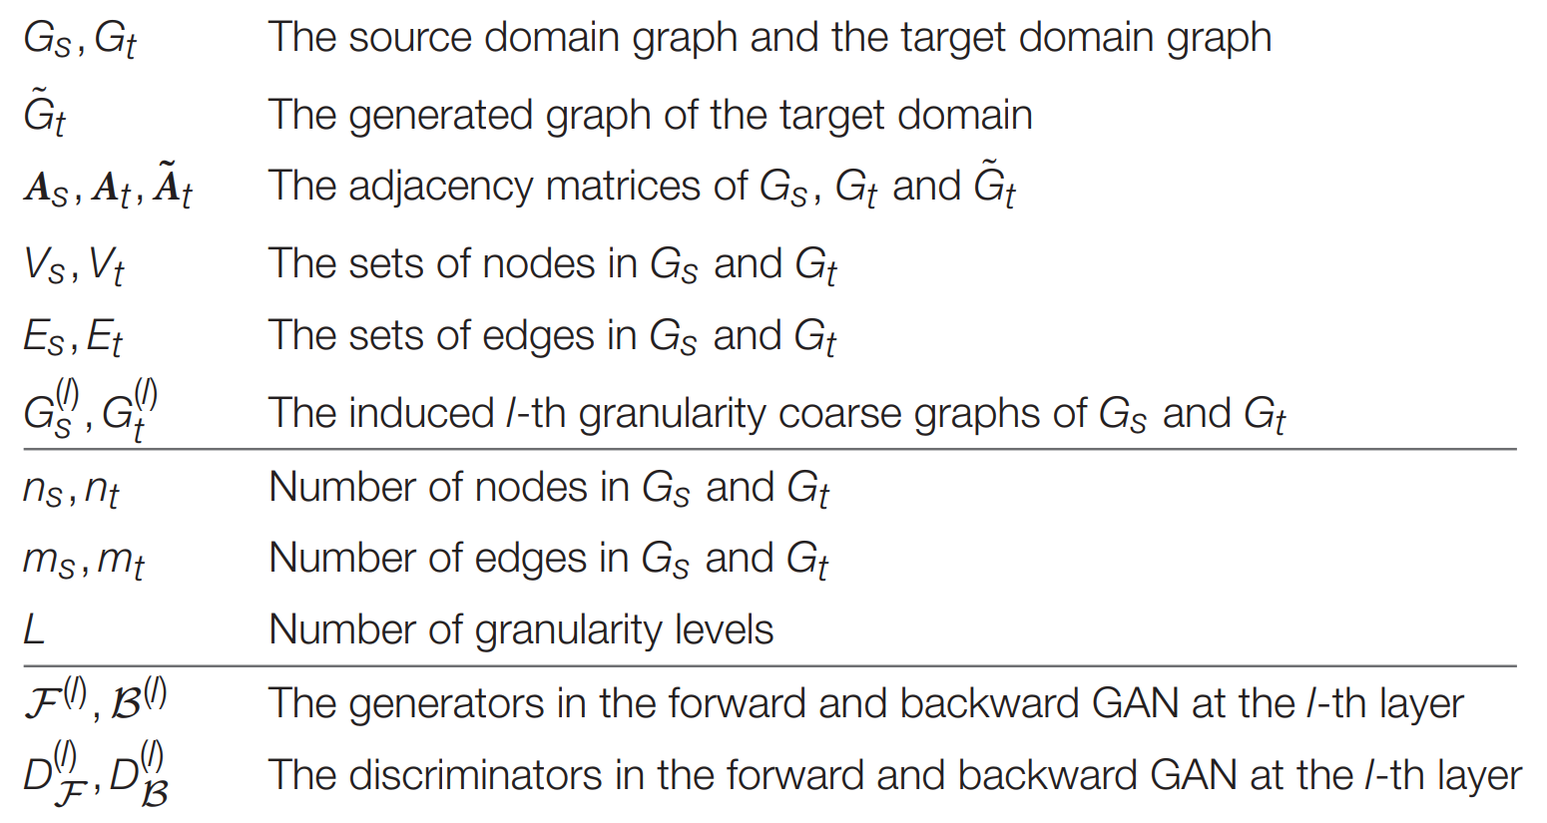

The framework can be separated into three stages:

Multi-Scale Graph Representation Module:

The Multi-Scale Graph Representation Module is a key component of the Misc-GAN framework.

This module is designed to explore the hierarchical cluster-within-cluster structures in order to better characterize the given graph.

In this module, the hierarchical structures of the input graph are explored by constructing coarse graphs at different levels of granularity.

This is achieved using multi-scale approaches such as hierarchical clustering and algebraic multigrid (AMG).

The goal of this module is to capture the complex organization of the graph at multiple scales, which is essential for modeling the non-unique, high-dimensional nature of graphs, as well as the graph community structures at different granularity levels.

Graph Generation Module:

The Graph Generation Module is another crucial component of the Misc-GAN framework.

This module is responsible for generating new graphs that preserve the hierarchical structure distribution over the observed target graph.

The Graph Generation Module uses a deep model for learning characteristic topological features from the given graphs via generative adversarial networks (GAN).

This involves efficiently learning the complex joint probability of all the nodes and edges from an observed set of graphs.

The goal of this module is to generate new graphs that are similar to the input graphs in terms of their hierarchical structures at different levels of granularity.

This is achieved by “transferring” the learned hierarchical distribution to a unique graph representation.

The Graph Generation Module is a key part of the Misc-GAN framework’s ability to model the underlying distribution of graph structures at different levels of granularity and generate new graphs that preserve these structures.

Graph Reconstruction Module:

The Graph Reconstruction Module is the final stage in the Misc-GAN framework.

This module is responsible for reconstructing the graph while preserving the important local structures that were captured in the Multi-Scale Graph Representation Module.

In this module, the concept of multi-scale analysis is adopted to capture the local structure of graphs at different resolution levels.

The goal is to reconstruct the graph in such a way that these important local structures are preserved.

This process involves formulating the framework into a generic optimization problem.

The details of this module, along with the multi-scale graph representation module and the graph generation module, are discussed in the proposed framework.

The Graph Reconstruction Module is a key part of the Misc-GAN framework’s ability to model the underlying distribution of graph structures at different levels of granularity and generate new graphs that preserve these structures.